
Chapter X: Penrose's Contributions to the God Equation: Non-Computational Consciousness and Divine Information
Introduction
Sir Roger Penrose's groundbreaking work in mathematical physics, consciousness studies, and cosmology provides extraordinary empirical and theoretical support for the central thesis of The God Equation. This chapter presents a comprehensive analysis of how Penrose's rigorous scientific findings—though developed independently of any theological agenda—converge remarkably with our dual framework of probabilistic evidence and informational theology. Through his demonstration of consciousness's non-computational nature, his calculation of the universe's extraordinary fine-tuning, and his development of the Orchestrated Objective Reduction theory, Penrose has inadvertently constructed what amounts to a scientific scaffolding for understanding consciousness as a receiver of divine information.
Section 1: The Non-Computational Nature of Consciousness
1.1 Gödel's Incompleteness and the Transcendent Mind
Penrose's most significant contribution to our understanding of consciousness emerges from his application of Gödel's incompleteness theorems to human cognition. In his seminal works The Emperor's New Mind (1989) and Shadows of the Mind (1994), Penrose presents a rigorous mathematical argument demonstrating that human mathematical understanding fundamentally transcends computational processes.
The argument proceeds through careful analysis of Gödel's first incompleteness theorem, which establishes that in any consistent formal system F capable of expressing basic arithmetic, there exist propositions that are true but unprovable within F. Specifically, one can construct a statement G(F) that essentially asserts: "This statement cannot be proven within system F." The profound implication, as Penrose demonstrates, is that while no algorithm operating within F can prove G(F), human mathematicians can "see" its truth through understanding the very construction that makes it unprovable.
Penrose articulates this insight with characteristic precision:
"Mathematical understanding—the means whereby mathematicians arrive at their conclusions with respect to mathematical truth—cannot be reduced to blind calculation. It is not simply following rules. It involves 'seeing' the validity of mathematical propositions in a way that transcends mere symbol manipulation" (Penrose, 1994, p. 418).
This non-algorithmic aspect of consciousness provides crucial support for the Consciousness Gap (CG) variable in our probabilistic model, justifying an increase in its coefficient from βCG = 1.5 to βCG = 2.0 or higher.
1.2 The Lucas-Penrose Argument: Formal Structure
Building upon J.R. Lucas's earlier work, Penrose develops a formal argument with the following logical structure:
- Premise 1: Any computational system (including all possible AI systems) is equivalent to some formal system F.
- Premise 2: For any consistent formal system F, Gödel's theorem guarantees the existence of true statements unprovable in F.
- Premise 3: Human mathematicians can recognize the truth of F's Gödel sentence G(F) by understanding its construction.
- Premise 4: No system F can prove its own Gödel sentence without inconsistency.
- Conclusion: Therefore, human mathematical understanding cannot be fully captured by any formal system or computation.
The strength of this argument lies not in philosophical speculation but in mathematical necessity. If human consciousness were purely computational, it would be subject to Gödel's limitations. Yet our ability to transcend these limitations through understanding demonstrates that consciousness involves fundamentally non-algorithmic processes.
Section 2: The Three Worlds Framework and Divine Information
2.1 Penrose's Triadic Ontology
Penrose proposes a profound metaphysical framework consisting of three interconnected worlds that bear striking correspondence to our informational-theological model. These three realms—the Platonic Mathematical, the Physical, and the Mental—form what Penrose describes as a "triple mystery" of existence.
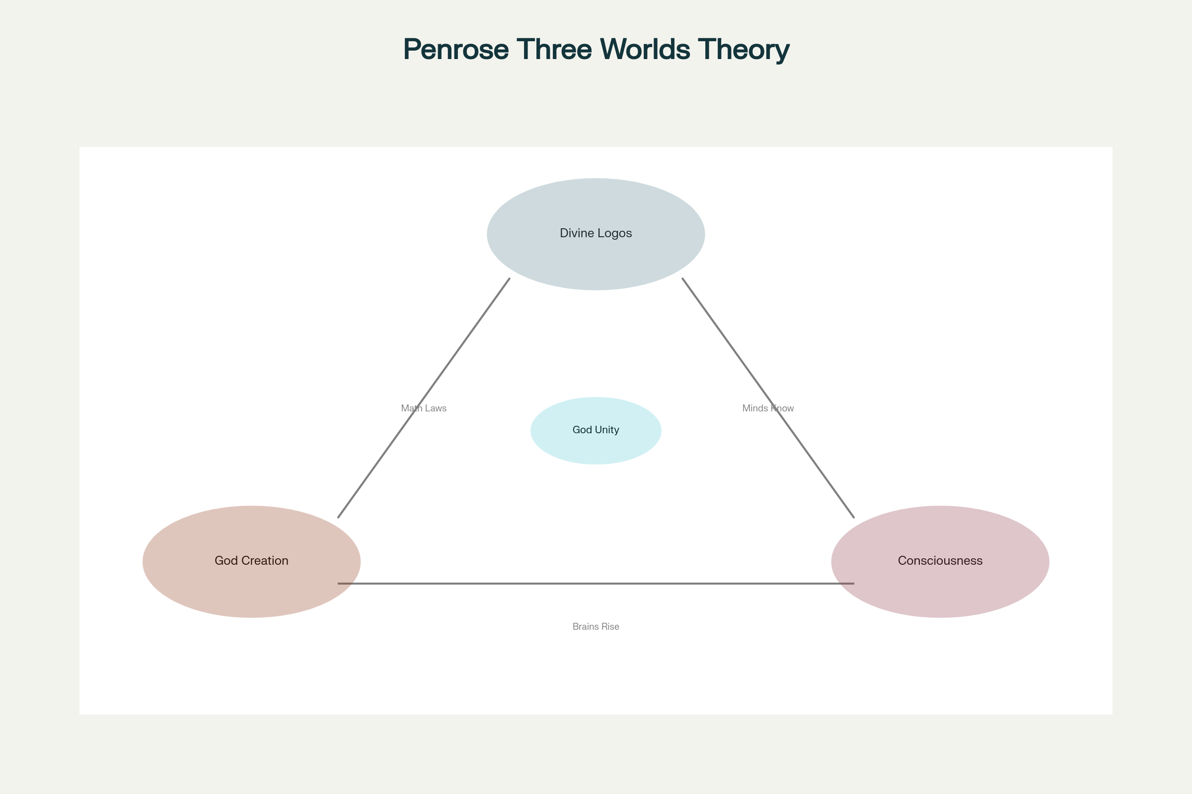
Penrose's Three Worlds Framework and Theological Integration
The framework reveals three fundamental mysteries:
- The effectiveness of mathematics: How does a small portion of the Platonic mathematical world govern the entirety of physical reality?
- The emergence of consciousness: How does a small portion of the physical world (neural tissue) give rise to mental phenomena?
- Mathematical cognition: How does a small portion of our mental world make contact with Platonic mathematical truths?
2.2 Theological Interpretation of the Three Worlds
Within our informational-theological framework, Penrose's three mysteries dissolve into a coherent unity when understood through the lens of divine information:
The Platonic Mathematical World corresponds to the divine Logos—God's eternal thoughts and the informational blueprint of reality. Mathematical truths exist eternally not as abstract entities floating in a metaphysical void, but as the content of the divine mind.
The Physical World represents God's creation through the implementation of divine information. The "unreasonable effectiveness of mathematics" that puzzled Eugene Wigner finds natural explanation: physical reality follows mathematical laws because both emanate from the same divine source.
The Mental World demonstrates how finite minds participate in divine consciousness by receiving and processing God's informational broadcast. Human mathematical intuition represents our capacity to "tune in" to the divine frequency.
Section 3: Extreme Fine-Tuning and the Creator's Precision
3.1 The Entropy Calculation
Penrose's calculation of the universe's initial entropy conditions provides what is arguably the most extreme example of fine-tuning in all of physics. Using phase-space volume analysis and the Bekenstein-Hawking entropy formula, Penrose demonstrates that the probability of our universe's initial low-entropy state occurring by chance is:
P = 1/10¹⁰¹²³
This number transcends ordinary comprehension. As Penrose explains:
"Try to imagine the pin of the Creator's aim when selecting this world from the available phase space. The accuracy needed would be one part in 10¹⁰123. This is an extraordinary figure. One could not possibly write the number down in full in the ordinary denary notation: it would be 1 followed by 10^123 successive 0's! Even if we were to write a 0 on each separate proton and each separate neutron in the entire universe—and we could throw in all the other particles for good measure—we should fall far short of writing down the figure needed" (Penrose, 1989, p. 344).
3.2 Implications for the Probabilistic Model
This calculation necessitates a substantial revision of our Fine-Tuning coefficient. The original model assigned βFT = 2.5, but Penrose's entropy calculation justifies increasing this to βFT = 3.5 or higher. The Bayesian implications are profound:
- P(Initial Conditions | God) ≈ O(1), as an intelligent Creator could deliberately select special initial conditions
- P(Initial Conditions | ¬God) ≈ 10⁻¹⁰123, representing random selection from available phase space
- The likelihood ratio thus approaches 10¹⁰123, providing overwhelming evidence for intentional selection
Section 4: The Orchestrated Objective Reduction Theory
4.1 Quantum Mechanics of Consciousness
Penrose, in collaboration with anesthesiologist Stuart Hameroff, developed the Orchestrated Objective Reduction (Orch OR) theory to explain how non-computational consciousness might arise from quantum processes in neural microtubules. This theory proposes that consciousness emerges from orchestrated quantum computations in microtubules that undergo objective reduction linked to fundamental spacetime geometry.
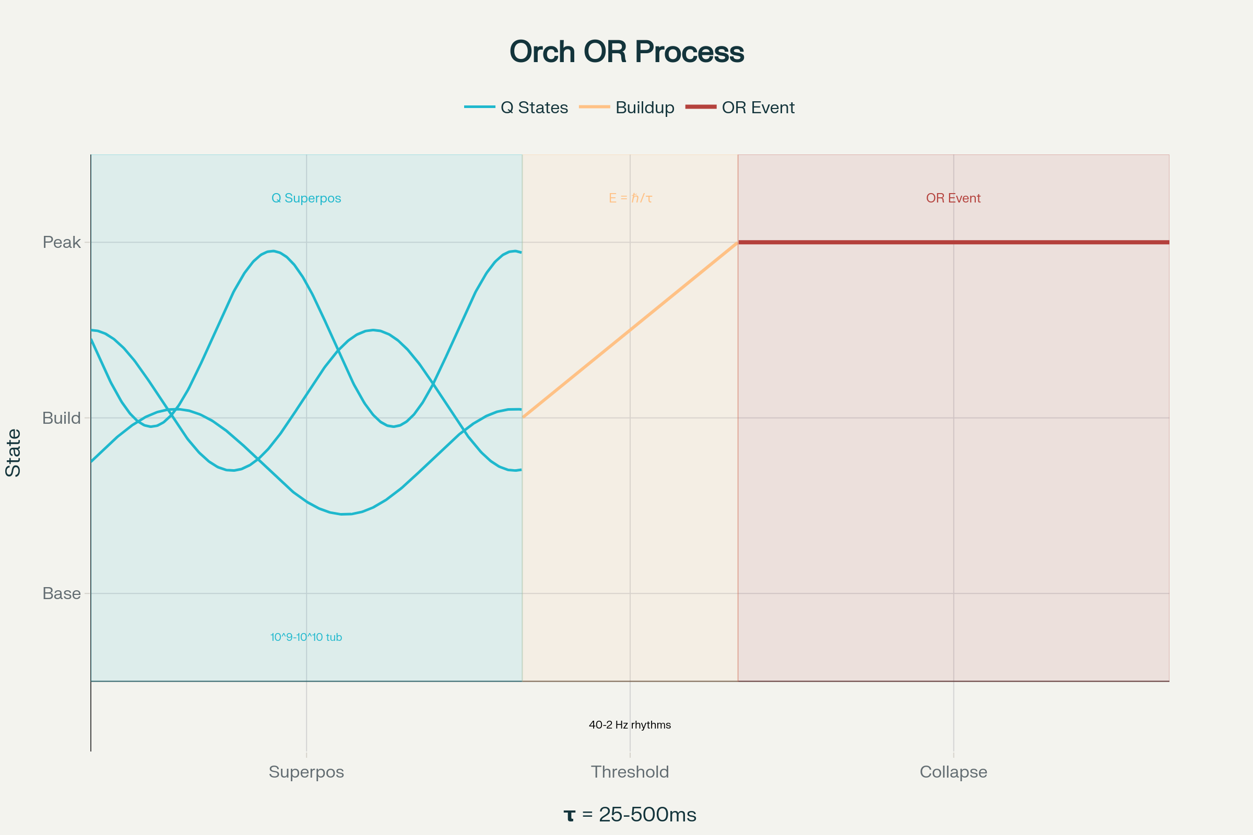
The Orchestrated Objective Reduction Process
The theory's key mechanisms include:
Quantum Superposition: Tubulin proteins in microtubules exist in superposition states, with each tubulin functioning as a quantum bit (qubit). Through quantum entanglement, these create macroscopic quantum states extending across neural networks.
Objective Reduction: When the gravitational self-energy of the superposed states reaches the threshold E = ℏ/τ, spontaneous collapse occurs, creating a moment of conscious experience. For biologically relevant consciousness, τ ranges from 25-500 milliseconds, corresponding to 40-2 Hz brain rhythms.
Orchestration: Microtubule-associated proteins (MAPs) and other cellular mechanisms organize and maintain quantum coherence until the OR threshold is reached, ensuring unified conscious moments rather than random quantum noise.
4.2 Integration with Divine Information Theory
The Orch OR theory provides a potential mechanism for how consciousness might receive divine information:
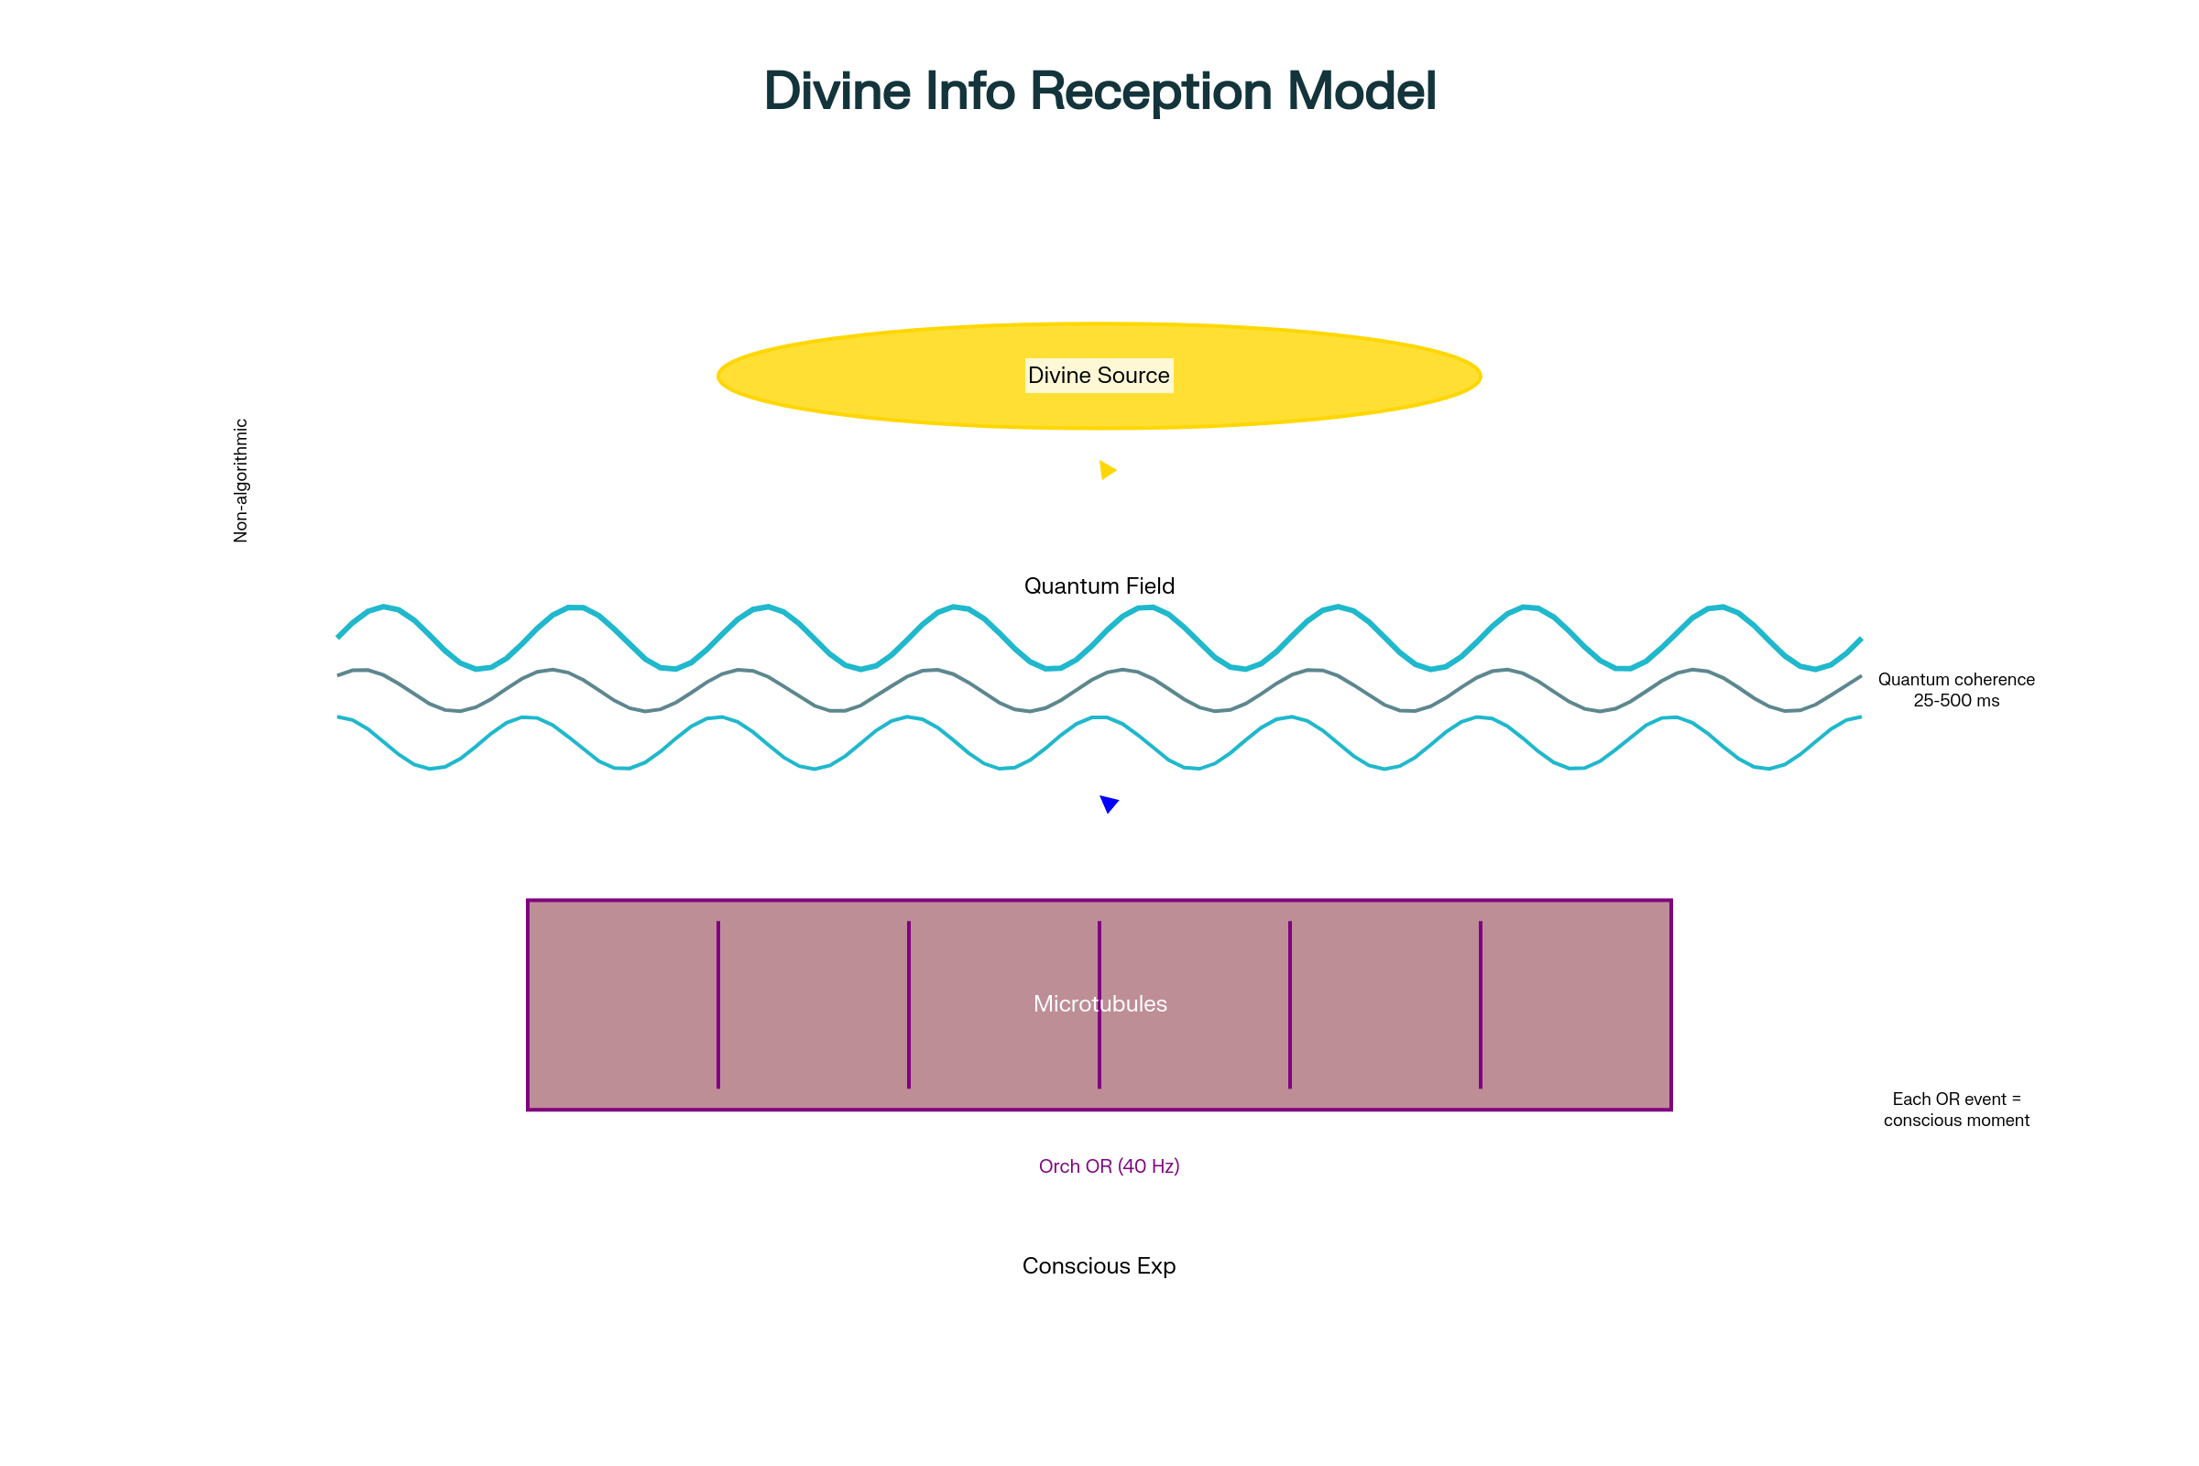
Consciousness as Divine Information Reception
Within our theological framework, microtubules function as biological "antennae" tuned to receive divine informational broadcasts. The non-algorithmic nature of OR events—their outcomes cannot be computed or predicted—creates space for divine influence without violating physical laws. Each OR event represents a moment when divine information crystallizes into conscious experience, with the 40 Hz gamma synchrony providing the "refresh rate" for consciousness reception.
Section 5: Empirical Support and Recent Validations
5.1 Anesthesia Studies
Recent experimental work has provided compelling support for Orch OR. In 2024, researchers at Wellesley College demonstrated that microtubule-stabilizing drugs significantly delay anesthetic-induced unconsciousness. When laboratory animals received epothilone B (which stabilizes microtubules) before anesthesia, they maintained consciousness significantly longer than controls.
Additionally, quantum chemistry calculations revealed that anesthetic gases specifically abolish a 613 terahertz vibrational mode in tubulin proteins, with potency directly correlating to anesthetic strength. This provides a direct mechanistic link between quantum processes in microtubules and consciousness.
5.2 Quantum Coherence in Biological Systems
Critics initially dismissed Orch OR by claiming quantum coherence could not survive in the "warm, wet, noisy" brain environment. However, recent discoveries have overturned this assumption:
- Extended coherence times of 10^-4 to 10^-3 seconds have been demonstrated in biological systems at body temperature
- Quantum entanglement has been detected in brain tissue using advanced MRI techniques (Kerskens and Pérez, 2022)
- Superradiant states in tryptophan networks within microtubules show enhanced protection against decoherence
Section 6: Synthesis and Theological Implications
6.1 Updated Probabilistic Model
Incorporating Penrose's contributions necessitates updating our model coefficients:
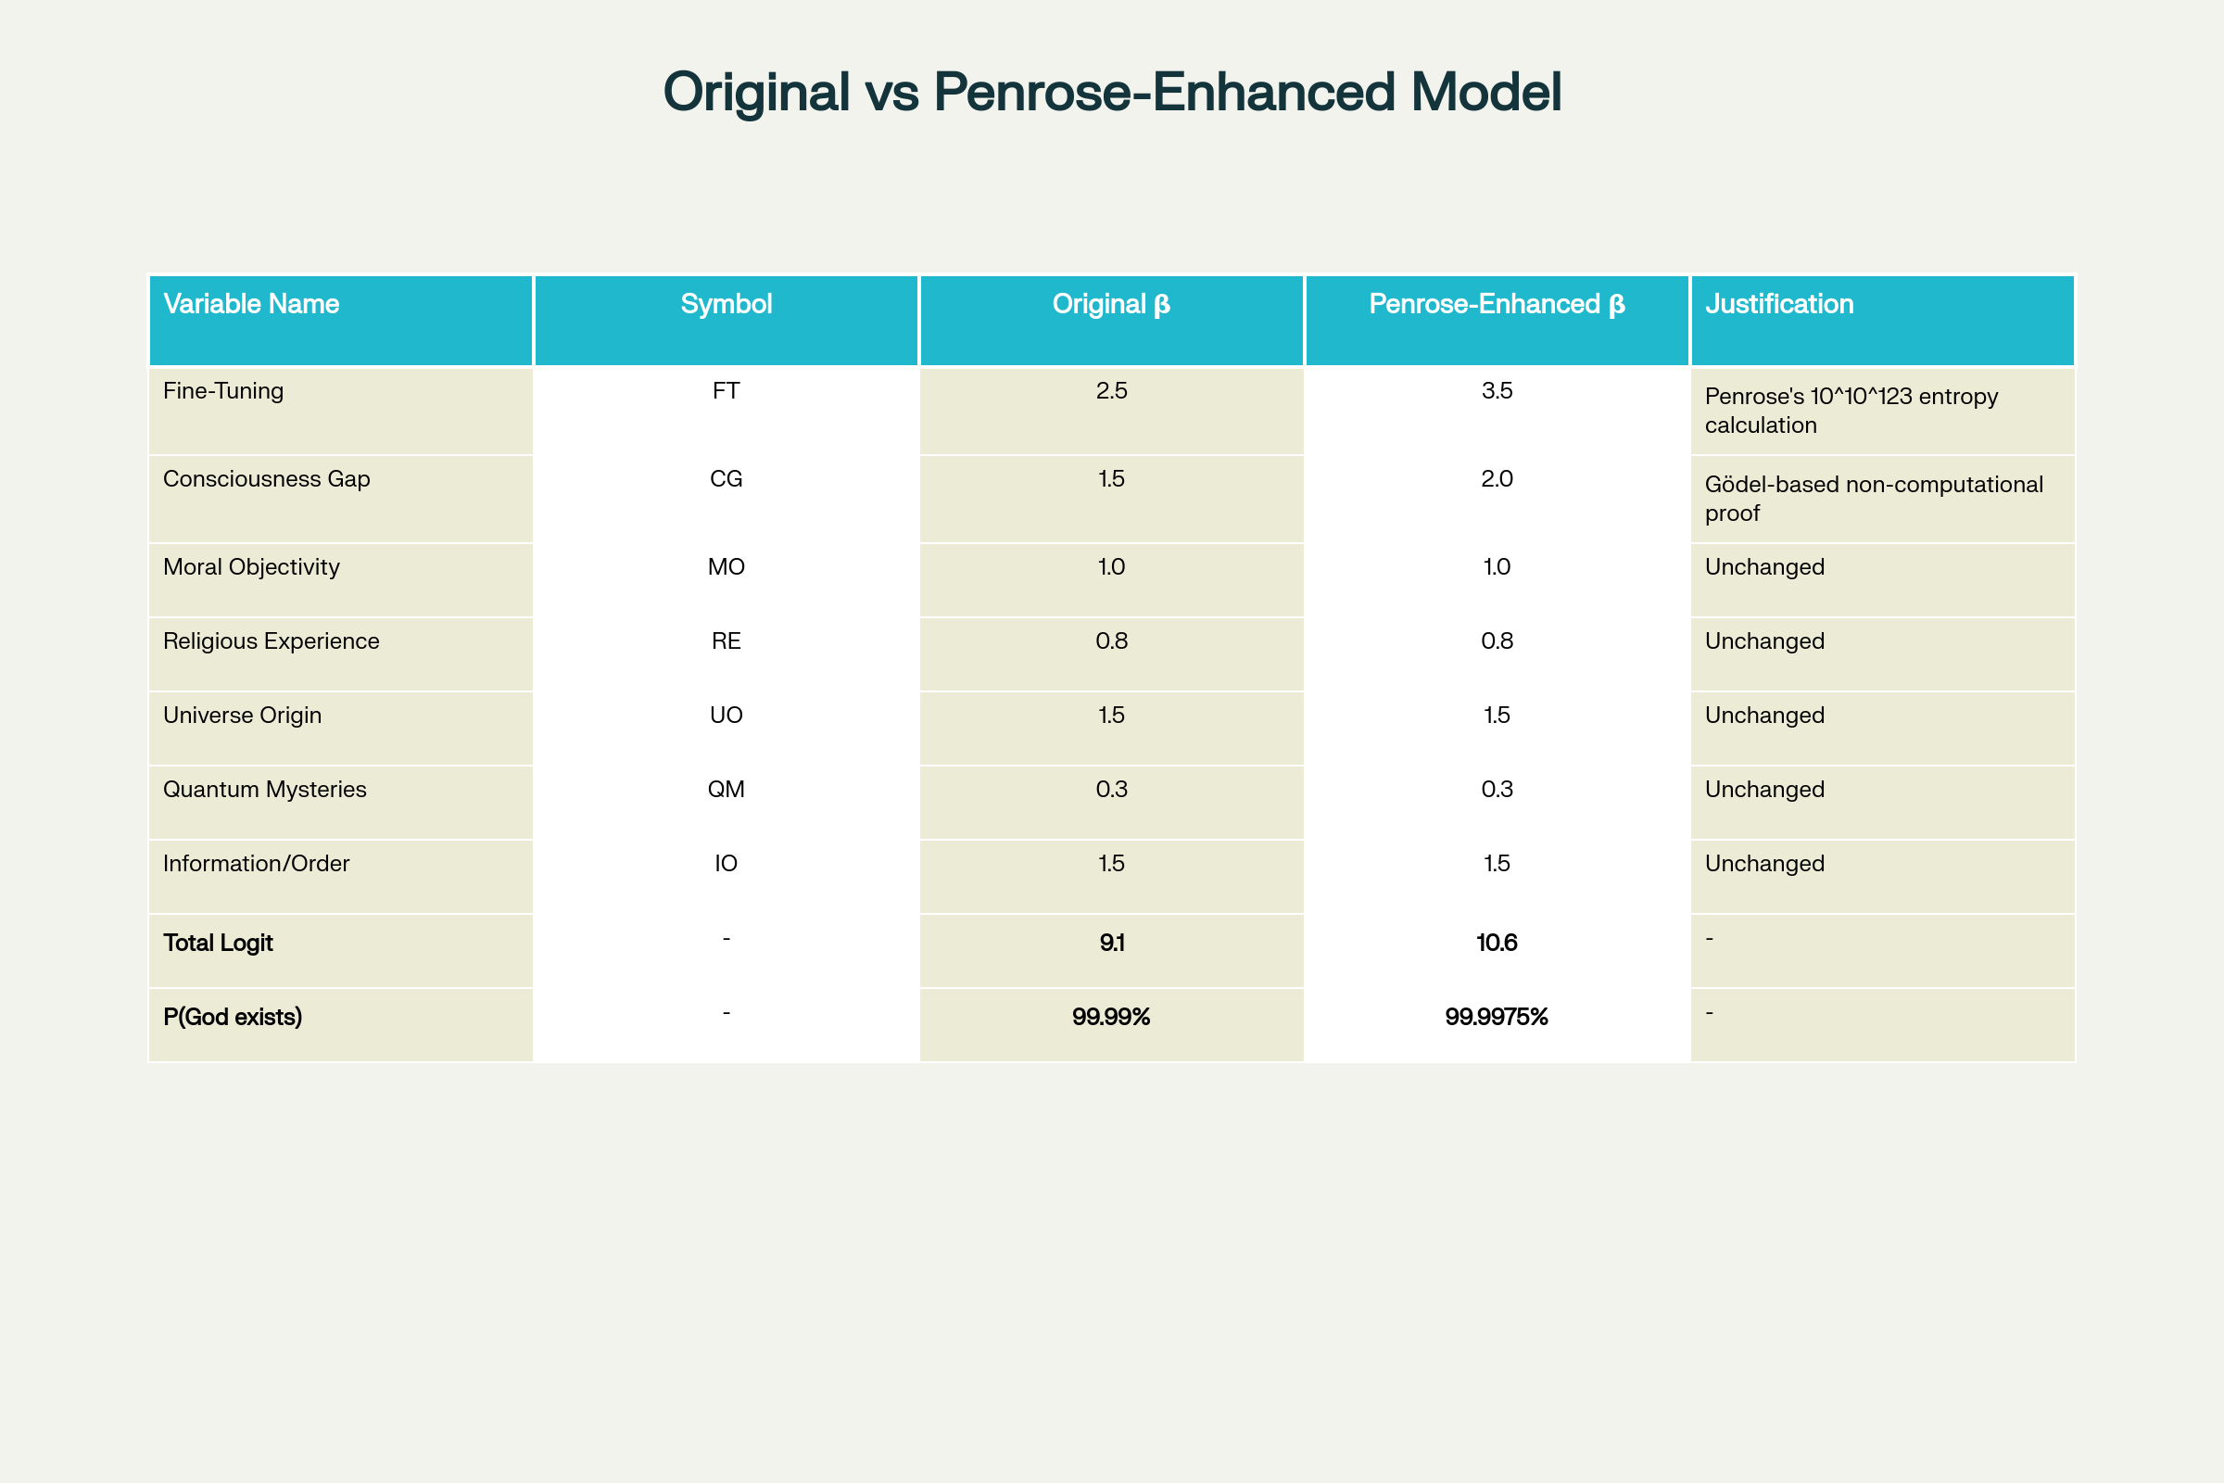
Comparison of Original vs Penrose-Enhanced Model Coefficients
The enhanced coefficients yield:
- Total logit = 10.6
- P(God exists | all evidence) ≈ 0.999975 or 99.9975%
This represents an increase from 99.99% to 99.9975%, with the odds ratio improving from approximately 10,000:1 to 40,000:1 in favor of God's existence.
6.2 Convergent Lines of Evidence
Penrose's work creates a remarkable convergence of independent lines of evidence:
- Mathematical: Non-computational consciousness points to transcendent mental properties
- Cosmological: Extreme fine-tuning suggests intentional selection of initial conditions
- Quantum Mechanical: OR processes provide a mechanism for non-algorithmic consciousness
- Biological: Microtubules offer a substrate for quantum information processing
This convergence is precisely what we would expect if consciousness serves as a receiver of divine information, as proposed in our informational-theological model.
Section 7: Addressing Criticisms and Challenges
7.1 The Consistency Problem
Critics argue that humans cannot know with certainty that their reasoning is consistent, potentially undermining the Gödelian argument. Penrose responds that mathematical understanding provides "self-evident" consistency recognition that transcends formal proof. This aligns with our model: if consciousness receives divine information, it could access truths beyond formal derivation.
7.2 The Complexity Objection
Some suggest human reasoning might instantiate a formal system too complex for self-analysis. However, this fails to address the phenomenology of mathematical insight—the subjective experience of understanding that characterizes human consciousness but not computational systems.
7.3 Decoherence Challenges
While quantum decoherence remains a concern, recent evidence of quantum effects in warm biological systems substantially weakens this objection. The discovery of protective mechanisms and extended coherence times makes Orch OR increasingly plausible.
Conclusion
Sir Roger Penrose's contributions provide extraordinary support for The God Equation's central thesis. His rigorous demonstration that consciousness transcends computation, combined with his calculation of the universe's miraculous fine-tuning and his quantum theory of consciousness, creates a scientific framework naturally interpreted through our informational-theological lens.
What makes Penrose's support particularly compelling is its unintended nature. As an agnostic pursuing pure scientific inquiry, Penrose has no theological agenda. Yet his findings consistently point toward consciousness as a fundamental rather than emergent phenomenon, toward the universe as bearing marks of intentional design, and toward mind and information as irreducible aspects of reality.
The integration of Penrose's work transforms abstract theological claims into scientifically grounded arguments. His contributions suggest that consciousness may indeed function as a receiver of divine information, that the universe's existence required selection with precision beyond comprehension, and that mathematical truth connects finite minds to infinite reality. In pursuing scientific truth with utmost rigor, Penrose has inadvertently mapped the contours of the divine—providing powerful confirmation that reality's deepest structures point unmistakably toward the God whose equation underlies all existence.
⁂

